`

Perkins Products
Braille Display

User’s Manual
Version 5.0 (Draft)
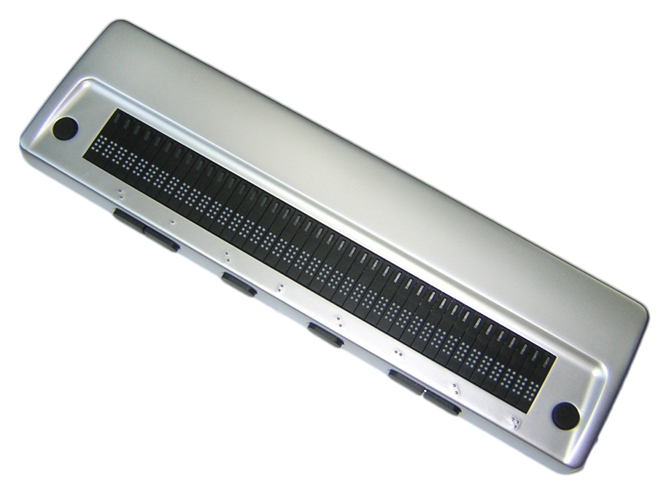

Preface

Thank you very much for purchasing the Perkins Products Braille Display. The Perkins Products refreshable Braille display provides a tactile interface to your computer. Before using the Perkins Products display, please read this user’s manual.

If there is anything that you don’t understand about using the display, or if you find mistakes or omissions in this user’s guide, please contact your distributor by letter, FAX, or telephone.

Our Perkins Products Braille displays are also known as Seika. It would be quite costly for us, or the manufacturer to include a second Seika driver entitled Perkins Products. In order to help keep the cost lower on our products we have decided to continue using the name Seika for related drivers.

What Comes in the Box?

For your Perkins Products Version 5 Braille Display, you will find there are two layers to unpack. On the top layer you will find the USB cable that you would use when connecting your device via USB and the cd containing drivers and manuals. Also, in the space with the USB cable you will find a very small thumb drive and an adapter to turn a USB port into a Bluetooth connecter.

Underneath the first layer are the rest of the items. Starting from the left, you will find the power adapter, case strap, and cable to connect the adapter to the computer. (Please plug the USB end into the power adapter.) At the back of the box you will find a piece of foam, lift this to find the display in the carrying case.

Please save the box and packing material in case you ever need to ship your unit.

Safety Precautions:

This User’s manual describes safety precautions according to the following level and marks of warning.
Warning mark | Mark to Prohibit | Procedures
 |  | 
Warning Caution | Actions Prohibited | Disconnect the power plug
This precaution must be followed, or it could cause fire or electric shock which could result in serious injuries or death.

【Warning】

This precaution must be followed, or it may cause electric shock and/or any other accidents which may result in injuries and/or partial damage of the products or surrounding equipment.

【Caution】

- Unauthorized reproduction of this document, in whole or in part, is strictly prohibited.
- Modifications to the contents of this document for improvements or revisions may be made without prior notification.
- Product liability is limited within the country of original purchase.

Table of Contents

Quick Installation Guide 5
Chapter 1 – Overall description of the Perkins Products Braille Display 1
1. Name and Functions of All Components 1
1.1 Overall Illustration of the Product 1
1.2 Description of the right side 4
1.3 Description of the left side 5
2. Three Working Modes 5
3. Beeps and Alarms 6
4. Sleep mode 6
Chapter 2 - Setup 7
1. Service Precautions (at setup time) 7
2. Installation Space 7
3. Operating Environment 8
4. Precautions for Moving 8
Chapter 3 - Perkins Products Braille Display Driver 9
Chapter 4 – Configuring the Bluetooth Connection 10
Chapter 5 - Connecting The Perkins Products Braille Display with IPad, IPhone and ITouch………………………………………………………………...12
Chapter 6 – Using the Perkins Products Braille Display with JAWS 13
1. Installing Seika Patch for JAWS 12
2. Working in JAWS 12
2.1 Configuring JAWS 12
2.2 Navigation and control keys function 16
3. Uninstalling the JAWS patch 18
3.1 Uninstalling the old version of the JAWS patch 18
3.2 Uninstalling the current version of the patch for Jaws 18
Chapter 7 – Using Perkins Products Braille Display with Window-Eyes 19
1. Working in Window-Eyes 19
1.1 Configuring Window-Eyes 7.2 19
1.2 Configuring Window-Eyes 7.5 20
2. Navigation and Control keys function 23
3. Updating the Seika Braille Display patch for Window-Eyes 24
Chapter 8 – Using the Perkins Products Braille Display with HAL Supernova 25
1. Working in HAL and Supernova 25
1.1 Configuring HAL Version 10 25
1.2 Configuring Supernova Version 11 and Version 12 28
2. Navigation and Control keys function 34
Chapter 9 – Using the Perkins Products Braille Display with COBRA 36
1. Configuring COBRA 36
2. Navigation and Control keys function 38
Chapter 10 – Using the Perkins Products Braille Display with NVDA 39
1. Configuration of BRLTTY 39
2. Configuration of NVDA 39
3. Reconnection 40
4. Navigation and Control keys function 40
Chapter 11 – FLASH DISK READING MODE 41
1. Quick Start 41
2. Control keys 42
2.1. File Selection 42
2.2. File Reading 43
3.Quit 43
Chapter 12 - Display Specifications 44
Q&A 45
1. How to verify which Virtual COM port has been used by the Perkins Products Braille Display 45
2. How to uninstall the Perkins Products Braille display driver 45
3. Braille display doesn’t work 45
3.1 Check the Perkins Products Braille display driver 46
3.2 Check the screen reader configuration 46

Quick Installation Guide

- The below steps assume that you have installed the screen reader and windows in their default locations.
- Install the Perkins Products Braille display driver (refer to Chapter 3).
- Install the Seika patch program and configure your screen reader (refer to Chapter 5 for Jaws, Chapter 6 for Window-eyes, Chapter 7 for HAL and Supernova, Chapter 8 for COBRA, Chapter 9 for NVDA).

Chapter 1 – Overall description of the Perkins Products Braille Display

1. Name and Functions of All Components

1.1 Overall Illustration of the Product
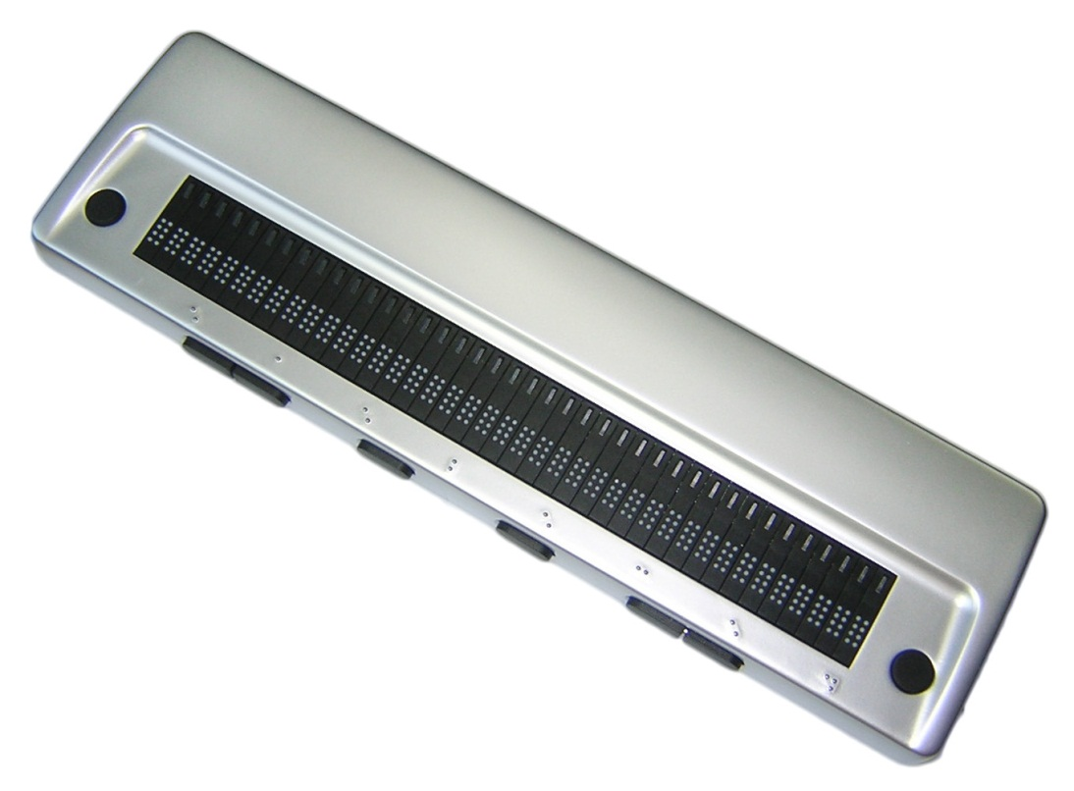
12
10
9
1
3
2
4
5
6
7
8
11

1–8: Navigation and Control Keys
9: Power Switch
10: USBPort for flash disk
11: MiniUSB Port
12: Display

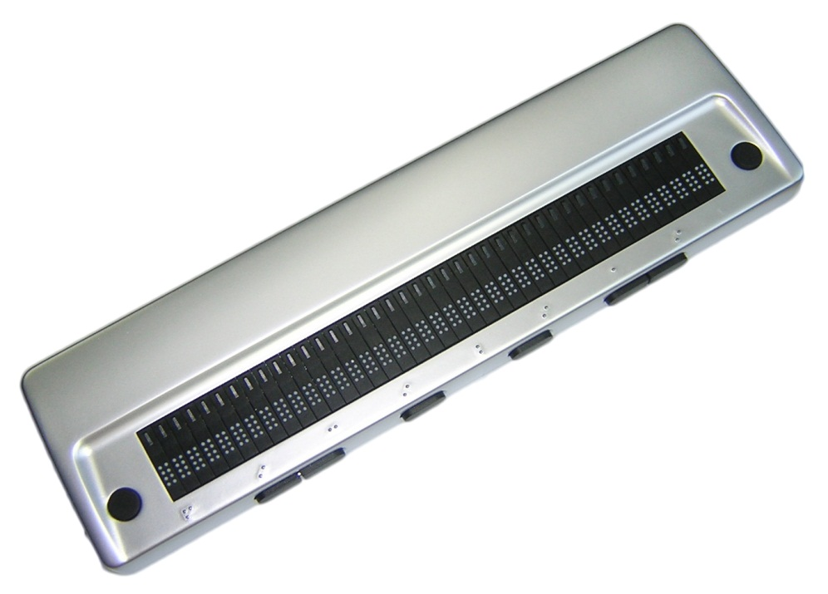
13

13: DC IN

Perkins Products Braille Display’s size:
12.99(W) x 3.58(D) x 0.98(H) inches and weight: 640g

Display
There are 40 refreshable Braille cells (8-pin).
【Caution】Please touch the Braille cell with clean finger, otherwise the dust will block the pins.

Cell Position Mark
It marks the cell position. There is the position mark per 5 cells. From left to right the position mark means the 5th, 10th, 15th, 20th, 25th, 30th, 35th, 40th cell.

Navigation and Control Keys
Place the Perkins Products Braille Display on a flat surface with the braille display facing upwards and the buttons facing towards you.
Top surface keys are located on the top of the Perkins Products Braille Display.
- Behind the Braille cells are the CURSOR ROUTING BUTTONS. These tiny buttons are used to move the computer's cursor directly to a particular location on the screen.
- Near each end of the Braille display is a small round button. The LEFT BUTTON is to the left and the RIGHT BUTTON is to the right.

Front panel navigation keys are located on the front edge, facing the user.
- On the left half of the front panel is the LEFT CTRL which contains LEFT CTRL LEFT and LEFT CTRL RIGHT.
- In the middle of the front panel are two buttons. The LEFT SHIFT is toward the left and the RIGHT SHIFT is toward the right.
- On the right half of the front panel is the RIGHT CTRL which contains RIGHT CTRL LEFT and RIGHT CTRL RIGHT.

1.2 Description of the right side
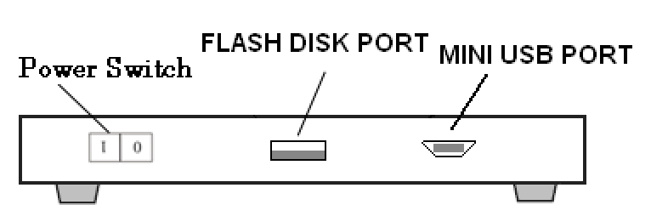

Power switch
On the right side of the display, there is the ON/OFF switch. Push the front side to turn on the display and push the rear side to turn off the display. When you connect the Braille display with the computer through Bluetooth or read flash disk, you need to turn on the display. If you connect the Braille display with the computer through a USB cable, the computer will power the Braille display, so you don’t need to turn on the switch.

Flash Disk Port

On the right side of the Braille display, there is a rectangular USB port. You can plug in a USB flash disk and read the files on it. Please refer to Chapter 9 for more details.

Mini USB Port
On the right side of the display, there is a Mini USB port which is used for connecting to the computer through a Mini USB cable.

1.3 Description of the left side

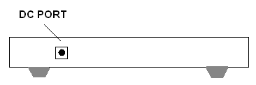

DC-IN
On the left side of the display, there is a 3.5 mm, DC 5V jack, with center pin positive. Plug the cord from the AC power adapter into the DC IN jack.

2. Three Working Modes
USB cable mode: The display works with the screen reader through a USB cable.
- Bluetooth mode: The display works with the screen reader wirelessly through Bluetooth.
- Reading flash disk mode: The unit displays the files on a flash disk.

【Caution】: Before you switch to other working modes, please power off the Perkins Products Braille display (Turn off the switch, pull out the Mini USB cable)

3. Beeps and Alarms
- Short beep once: The Braille Display is powered byadapter or battery.
- Beep twice: The Braille Display is powered by the computer through a USB cable.
- Beep one low tone and one high tone: Enter the Flash disk mode.
- Beep one hightone and one low tone: Flash disk is pulled out or exit the
Flash disk mode.
- Short beep three times: Braille Display shuts down automatically (no operation within one hour).
- Beep two high tone: The adapter is connected.
- Beep two low tone: The adapter is unconnected.
- Beep three down tone every ten minutes: low battery alarm.
- Beep three up tone: battery is charged fully.

4. Sleep mode
The Braille display will sleep if there is not any operation within one minute. You can wake up the Perkins Products Braille display by pressing any button or activating your screen reader.
The Braille display will shut down automatically if there is not any operation within one hour. You can wake up the Braille display by restarting power.

Chapter 2 - Setup

1. Service Precautions (at setup time)
【Prohibited】: Avoid using the display in the following conditions, which may cause malfunctions.
- Direct sunlight, near air conditioners or outside.
- High humidity, such as those near a water supply or humidifier, or any place with water, oil, or chemicals.
- Avoid contact with dust, waste particles, pet hair, near open windows, or locations with any toxic gases or iron powder.
【Caution】: Please touch the Braille cells with clean fingers, otherwise the dust will block the pins.

Also, do not install the display near any televisions, radios, speakers, short-wave radios, or anything that is magnetic or emits radio waves. If you use it adjacent to any of these items, it can interfere with reception.

2. Installation Space
【Caution】:Install the product in a location which meets the following criteria:

- The product must be installed on a level surface.
- It is recommended to avoid putting anything heavier than a keyboard or a laptop computeror similar on top of the device as it may cause malfunction.

3. Operating Environment
- Temperature: 41 – 95°F (5 – 35°C)
- Humidity: 20 - 80% (no condensation)

4. Precautions for Moving


【Warning】
- Violent shaking or vibrations at the time of moving may cause product failures.

【Requirement】
- Turn off the computer which is connected to the display, and disconnect the USB cable, then move the display.

Chapter 3 - Perkins Products Braille Display Driver
You can connect the Perkins Products Braille display to your computer through either the USB port or Bluetooth. If you use a USB cable, you need to install the driver. If you use Bluetooth, please refer to Chapter 4.

Installing Perkins Products Braille display driver
(Windows XP / Vista / Windows 7)

Before using the display with the screen reader, please install Seika Braille display driver. Make sure that the Braille display is not connected to your computer.

- Run“Seika Driver XP_Vista_Win7 V6.3a.exe” in the “Seika driver” folder on the CD.
- Select “Install” to install the Braille display driver.
- When prompted “Installation Successful”, press ENTER.
- Follow the instructions and restart your computer.
- The braille display driver is installed successfully.

Chapter 4 - Configuring the Bluetooth Connection
Bluetooth is a short-range wireless communication technology. The Perkins Products braille display with Bluetooth capability can communicate with a computer over a distance of about 10 meters (30 feet) without requiring a USB cable.

In order to use the Braille display through Bluetooth, you need to establish a partnership with a Bluetooth enabled computer. The majority of laptops offer built-in Bluetooth support. If your computer does not have built-in Bluetooth, you need to plug in an external USB Bluetooth dongle and install the appropriate drivers on your computer.

Here are instructions for setting up theBluetooth connection between the Braille display and computer.

- Do not plug in the USB cable.
- Turn on the Braille display. It beeps once, and it displays the firmware version information and Bluetooth name.
- Make sure that Bluetooth is enabled on the computer. If you are using an external USB Bluetooth adapter, insert it into your computer.
- Open Bluetooth control software, and search for Bluetooth devices. It will take several seconds. When the search is complete, the Braille display Bluetooth name TS5 is in the list of devices.
- Select TS5 from the list. If the computer doesn’t find the Braille display, please make sure you turn on the Braille display, and then search again.

- In the Bluetooth pin passkey edit field, type Braille display pin code“0000”.

- After a few seconds, you will receive a message that the Bluetooth device was successfully connected and the outgoing and incoming COM port assignments are displayed. Make a note of the outgoing port number as this is the port the screen reader will use to communicate with the Braille display.

Now please configure your screen reader to use the Bluetooth COM port. To configure the COM port in the screen reader, please refer to chapter 5 for Jaws, chapter 6 for Window-eyes, chapter 7 for HAL and Supernova, chapter 8 for COBRA and chapter 9 for Apple Products.

Chapter 5 - Connecting The Perkins Products Braille Display with an Apple IPad, ITouch or IPhone OS5 or higher
- Make sure that your Perkins Products Braille display is turned on.
- From your home screen and choose Settings.
- In the settings menu choose General.
- From the General menu choose Accessibility.
- In Accessibility choose VoiceOver.
- From VoiceOver choose Braille.
- If Bluetooth is not on then a dialog will pop up and ask if you want to turn it on. Say yes. Bluetooth needs to be turned on.
- In the braille menu under choose a Braille Device look for the display. It will start with TS5. Choose that device.
- It will then ask you to pair the device. Type in the pairing code 0000 and press the pair button.

Chapter 6 - Using Perkins Products Braille Display with JAWS
(For JAWS version 10.0.1154 and later)

NOTE:
The below steps assume that you have already installed the braille display driver and Jaws version 10.0.1154 or later. If you have not installed the braille display driver, please refer to Chapter3.
If you have already installed the older version of the Seika Patch for JAWS, please uninstall the old version of Seika patch refer to the 5.3.1 Uninstall the old version of the Seika patch for Jaws.

1. Installing the Seika Patch for JAWS
- Open the “Seika patch for JAWS” folder in the CD. Run the Seika Patch for JAWS according to your Windows operating system.
- Install the patch by default steps. The Seika Patch for JAWS will be installed by the JAWS Utility automatically. A console window appears and it will take several minutes.

2. Working in JAWS

2.1 Configuring JAWS
- Start JAWS and select “Braille…” in the “Options” menu.

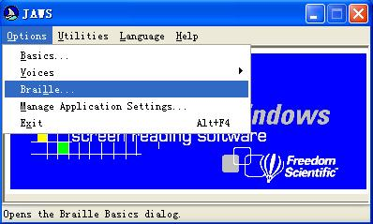

- Assuming that the default Braille display is set to “No display”, tab to the “Add Braille Display” button and press enter.
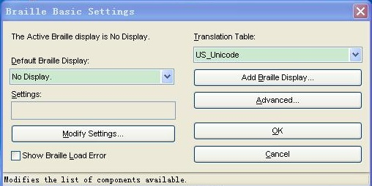

- In the “Select components” dialog box, there is a list of Braille displays. Select the “Seika” by pressing the space bar.
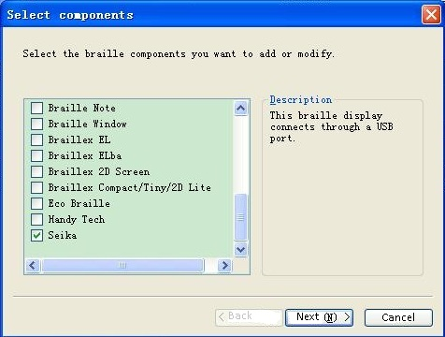

- Tab to the “Next” button and press enter.
- If you connected the Braille display with your computer by a USB cable, the output port will be set automatically, it does not need changing.
If you connected the display to your computer using Bluetooth, in the “Set device options” dialog box, select the output port that corresponds to the COM port number that you noted in chapter 4.

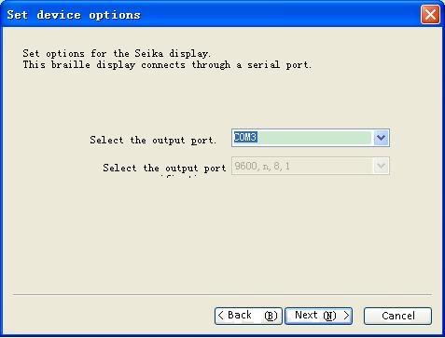
- Tab to the “Next” button and press enter.
- When prompted to set the primary device, select “Seika” in the “Primary device” list.

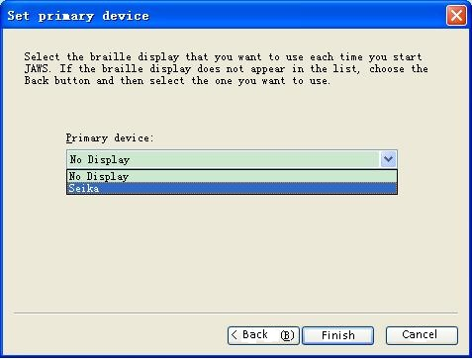
- Tab to the “Finish” button and press enter.
- In the “Braille Basic Settings” dialog box, tab to the “OK” button and press Enter.

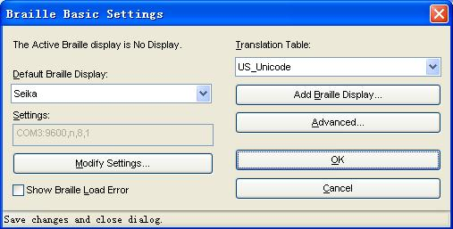

- Restart the JAWS and the Perkins Products Braille Display will work.

NOTE: if the braille display does not work with Jaws, please check the setting of the output port in Jaws through the following steps.

- Run the “Detect Seika COM Port V1.0.exe” in the “tool” folder on the CD; remember the COM port number.
- In the “Braille Basic Settings” dialog box, press the button “Modify Settings…”. In the “set device options” dialog box, you can manually select the output port which you remembered.

2.2 Navigation and control keys function

Left Ctrl Right
Left Ctrl Left
Left Shift
Right Shift
Right Ctrl Left
Right Ctrl Right
Right Button
Left Button

Braille Commands:

Description | Command
Braille Mode Toggle | Left Button + Right Button
Attribute/Character mode toggle | Left Ctrl Left + Right Ctrl Left
Adjust Braille Option Dialog | Left Ctrl Left + Left Shift
Attribute Marking Off | Left Button + Left Ctrl Left + Left Shift
Braille Marking Off | Left Button + Left Ctrl Left + Left Shift
8-Dot/6-Dot Toggle | Right Shift + Left Shift + Right Ctrl Right
8 Pixels/Unlimited Pixels Per Space | Left Shift + Right Shift + Right Ctrl Left
Repeat Last Flash Message | Left Ctrl Left + Right Ctrl Right

Navigation Commands:
Description | Command
Auto Advance Mode | Left Ctrl Right + Right Ctrl Left
Increase Auto Advance Speed | Left Button + Right Shift
Decrease Auto Advance Speed | Left Button + Left Shift
Top Of Window | Left Ctrl Left
Bottom Of Window | Left Ctrl Right
Pan Left | Left Button
Pan Right | Right Button
Braille Next Line | Right Ctrl Left
Braille Prior Line | Right Ctrl Right
PAGE DOWN (Active Cursor) | Left Ctrl Right + Right Shift
PAGE UP (Active Cursor) | Left Ctrl Left + Right Shift
TAB | Left Shift + Right Ctrl Left
CTRL+TAB | Left Ctrl Right + Right Button
SHIFT+TAB | Left Shift + Right Ctrl Right
CTRL+SHIFT+TAB | Left Ctrl Left + Right Button

Cursor Commands:
Description | Command
Braille follows Active | Left Shift
Active follows Braille | Left Shift + Right Shift
Route Braille To Active | Right Shift
Screen Reader Cursor | Right Button + Right Ctrl Left
Mouse Button Right Click | Left Shift + Right Button
PC Cursor | Right Button + Right Ctrl Right
Route Screen Reader to PC Cursor | Right Shift + Right Ctrl Right
Route PC to Screen Reader Cursor | Right Shift + Right Ctrl Left
Select Text | Any Cursor Routing Button+ Right Shift

3. Uninstalling the JAWS patch
NOTE: Uninstalling the JAWS patch will delete all the patch files.
You must uninstall this patch before uninstalling JAWS.

3.1 Uninstall the old version of Seika patch for Jaws
Open the “Add or Remove Programs” in the “Control Panel”, and select the item: “Seika Braille Display version 3” or “Seika Patch for JAWS V1.x” or “Seika Patch for JAWS V2.x”.Uninstall the item step by step. The uninstall will take several minutes. Please restart the computer after finishing.

3.2 Uninstall the current version of Seika patch for Jaws
Open the “Add or Remove Programs” in the “Control Panel”, and select the item: “Seika Patch for JAWS V2.3”.Uninstall the “Seika Patch for JAWS V2.3” step by step. The uninstall will take several minutes. Please restart the computer after finishing.

Chapter 7 - Using the Perkins Products Braille Display with Window-Eyes
NOTE:
The below steps assume that you have already installed the braille display driver and Window-eyes version 7.2 or later. If you have not installed Seika driver, please refer to Chapter3.

1. Working in Window-Eyes

1.1 Configuring Window-Eyes 7.2
- If you connect the Perkins Products Braille display to your computer using the USB cable, run the “DetectSeikaCOMPort V1.0.exe” in the “tool” folder in the CD, remember the display COM port number.
If you connect the display to your computer using Bluetooth, in the “Set device options” dialog box, select the output port that corresponds to the COM port number that you noted in chapter 4.
- Start Window-eyes 7.2.
- Select “File” in Window-Eyes, and then select “Select Braille Display”.
- Select “Seika” in “Braille” option.
- In “Ports” option, if you connect the braille display to your computer using USB, select the COM port number which you remembered.
If you connect the display to your computer using Bluetooth, select the COM port number that you made note of in chapter 4.
- Select OK button.

1.2 Configuring Window-Eyes 7.5
- If you connect the Braille display to your computer using USB cable, run the “DetectSeikaCOMPort V1.0.exe” in the “tool” folder in the CD, remember the COM port number.
If you connect the display to your computer using Bluetooth, in the “Set device options” dialog box, select the output port that corresponds to the COM port number that you noted in chapter 4.
- Run the “DetectSeikaCOMPort V1.0.exe” in the “tool” folder in the CD; remember the display COM port number.
- Start Window-eyes 7.5 and select “Device” in the “Settings”list.

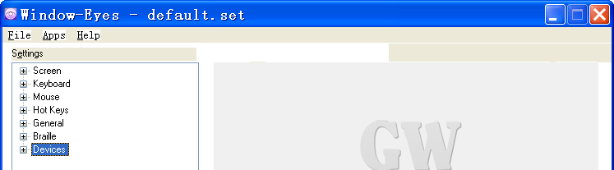

- Select “Braille Display” in the “Device” list.

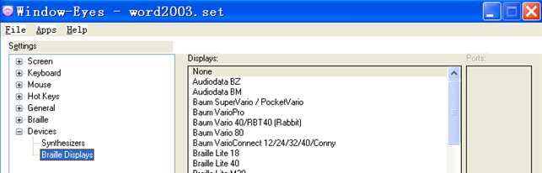

- In “Displays” option, select “Seika” option.
- In “Ports” option, if you connect the Braille display to your computer using USB, select the COM port number which you were asked to remember.
If you connect the display to your computer using Bluetooth, select the COM port number that you made note of in chapter 4.

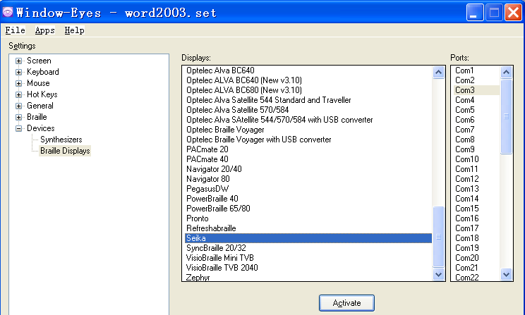

- Tab to the “Activate” button and press Enter.
- Select “Keep Changes” button in the “Braille Settings” dialog box, then press Enter.

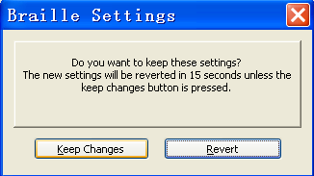

- Tab to “Save Settings” button and press Enter.

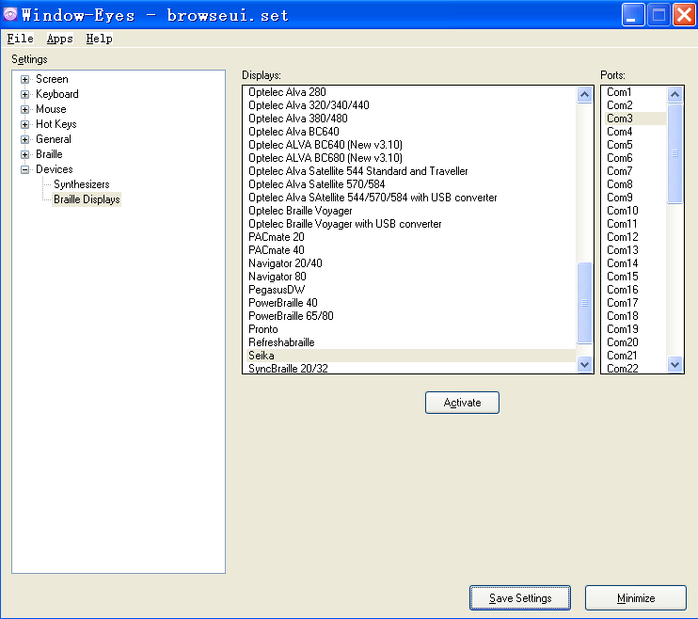

2. Navigation and Control keys function
Left Ctrl Right
Left Ctrl Left
Left Shift
Right Shift
Right Ctrl Left
Right Ctrl Right
Right Button
Left Button

Description | Key Press
Scroll Braille Left | Left Button
Scroll Braille Right | Right Button
Prior Braille Line | Left Ctrl Left
Next Braille Line | Left Ctrl Right
Top Line | Right Ctrl Left
Bottom Line | Right Ctrl Right
Mouse Top Left | Left Button + Left Ctrl Left
Mouse Bottom Left | Left Button + Left Ctrl Right
Mouse Top Right | Right Ctrl Left + Right Button
Mouse bottom right | Right Ctrl Right + Right Button
To Focus | Left Button + Right Button
Grade 2 Braille Toggle | Left Shift + Right Shift
Untranslate At Cursor | Left Shift + Right Ctrl Left
Untranslate At Mouse | Left Shift + Right Ctrl Right
Scroll Mode Toggle | Left Ctrl Left + Right Ctrl Left
Spacing Toggle | Left Ctrl Right + Right Ctrl Right
Attributes To Show Rotor | Left Ctrl Left + Right Shift
Show Attributes Toggle | Left Ctrl Right + Right Shift
Quick Message Rotor | Left Ctrl Right + Right Ctrl Left
Display Individual Attribute Rotor | Left Ctrl Left + Left Shift
Braille graphic mode | Left Ctrl Right + Left Shift
Toggle 6/8 Braille | Right Shift
Braille tracking toggle | Left Shift

3. Updating the Braille Display patch for Window-Eyes
Note:
You should manually update the Braille Display patch for Window-Eyes 7.5.1 or earlier version to support the Bluetooth of the Braille display. (The Window-Eyes 7.5.2 will include this update patch.)

Disconnect the Braille display from the computer.
- Find the installation directory for Window-Eyes first. For example:
32bit: C:\Program Files\GW Micro\Window-Eyes
64bit: C:\Program Files (x86) \GW Micro\Window-Eyes

You will find the update “webrloem107.dll”, ”SLABHIDDevice.dll”, “SLABHIDtoUART.dll” files in the “Seika Braille Display Driver for Window-Eyes” folder in CD or the update zip file, copy those to the Window-Eyes directory that you find in step2, and replace the older files if they exist.

Chapter 8 – Using the Perkins Products Braille Display with HAL and Supernova
(For HAL version 10 and later)

NOTE: The below steps assume that you have already install the braille display driver and HAL version 10 or later. If you have not installed the braille display driver, please refer to Chapter3.

1. Working in HAL and Supernova
Refer to the “1.1 Configuring HAL Version 10” or “1.2 Configuring Supernova Version 11and Version 12”.

1.1 Configuring HAL Version 10
- Run HAL.
- Open the HAL Control Panel Window.
- Select Configuration.
- Select SAM Set UP.

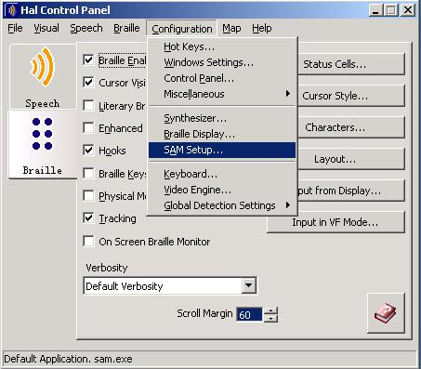

- Select “Detect All Devices now”.

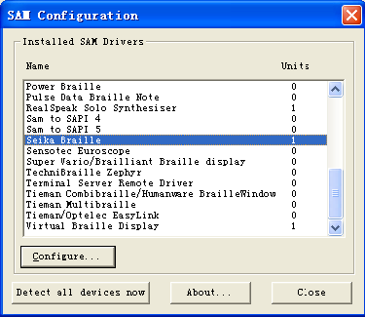

- HAL will automatically detect the Braille display.
- Return to the HAL Control Panel Window.
- Select “Braille Display”.

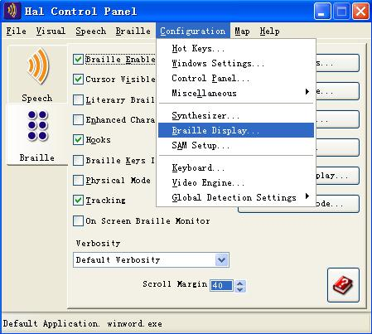

- Click “Select Braille Display”.
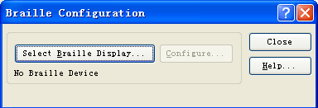

- Select the “Seika Braille”from the list and click “OK”.
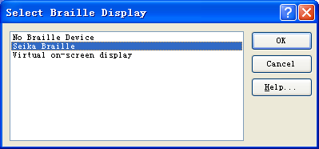

- Return to HAL Control Panel.
- Ensure that the On Screen Monitor is enabled.

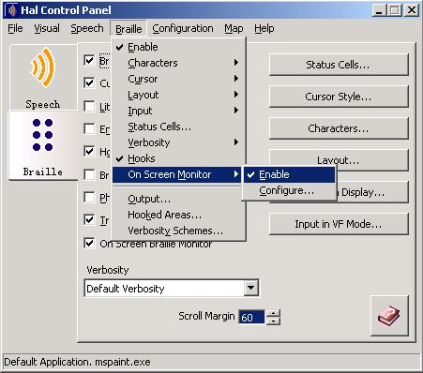

- Restart your HAL.

1.2 Configuring Supernova Version 11 and Version 12
- If you connect the Braille display to your computer using USB cable, run the “DetectSeikaCOMPort V1.0.exe” in the “tool” folder in the CD, remember the Seika COM port number.
If you connect the Perkins Products braille display to your computer using Bluetooth, in the “Set device options” dialog box, select the output port that corresponds to the COM port number that you noted in chapter 4.
- Run Supernova.
- On the “Supernova Control Panel”, select “Advanced Options…” from the menu item “General”.

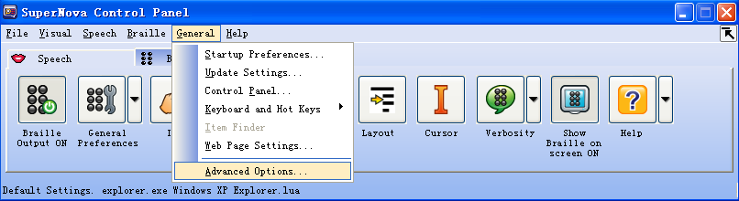

- Select “System Configuration” tab, choose “SAM Setup…” and press enter.
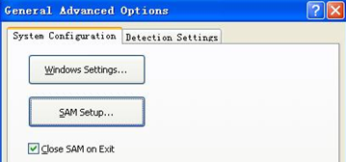

- Check the “Seika Braille” item on the “SAM Configuration” dialog box. Tab to the “Configure…” button and press enter.

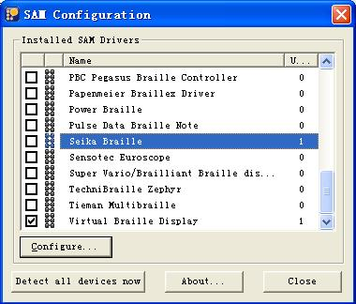

- Select the “Manual Configuration” radio button, tab to the “Serial Ports…” button and press enter.

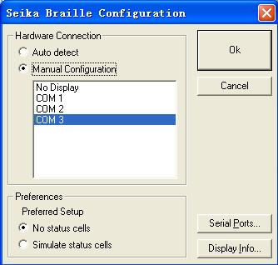

- In the list of COM ports, if you connect the Braille display to your computer using USB, select the COM port number which you remember and press “OK” button.
If you connect the display to your computer using Bluetooth, select the port that corresponds to the COM port number that you noted in chapter 4.
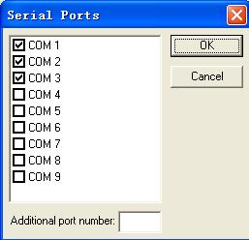

- In the “Seika Braille Configuration” dialog box, select the serial port you have just checked and tab to the “OK” button and press.

- In the “SAM Configuration” dialog box, the units of the Seika Braille is 1. The Perkins Products Braille display connection to the Supernova is successful. Tab to the “Close” button and press enter.

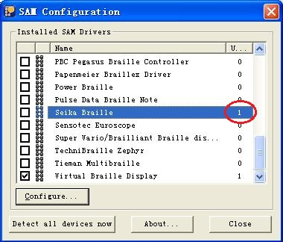

- Tab to the “OK” button and press enter in the “General Advanced Options” dialog box.
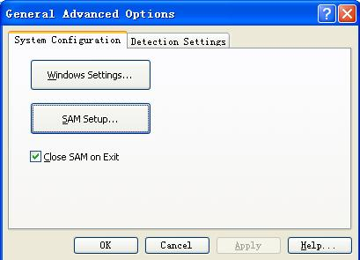

- On the “Supernova Control Panel”, select “General Preferences…” from the menu item “Braille”.
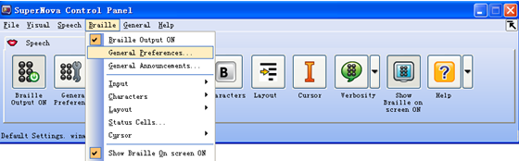

- Select “Braille Device” tab in the “General Preferences” dialog box, tab to the “Select Braille Display” button and press enter.

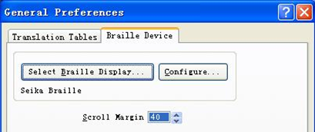

- Tab to the “Seika Braille” item in the “Select Braille Display” dialog box and press “OK” button.

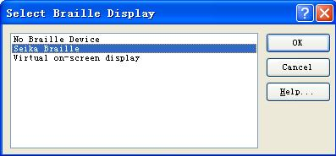

- Select “Translation Tables” tab in the “General Preferences” dialog box. Configure the “Unicode to Braille Conversion”, “Unicode to Literary Braille Conversion” and “Literary Braille Input” according to the local language. Tab to the “OK” button and press enter.

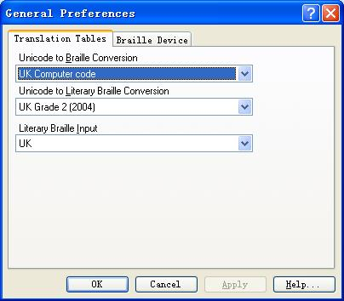

- Restart your Supernova and Perkins Products Braille Display will work.

*****NOTE: If you use another model Seika Braille display, please repeat the step of “1. Working in HAL and Supernova”.

2. Navigation and Control keys function
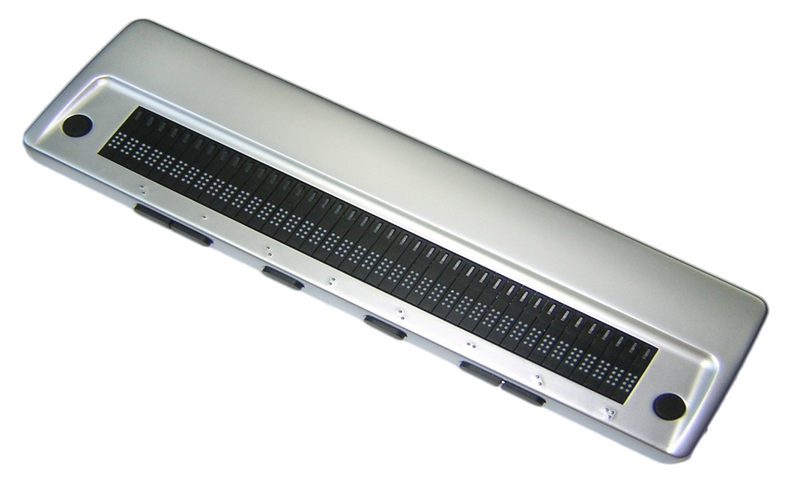
Left Ctrl Right
Left Ctrl Left
Left Shift
Right Shift
Right Ctrl Left
Right Ctrl Right
Right Button
Left Button

Action | Key press
Braille Back | Left Button
Braille Forward | Right Button
Braille Line up | Right Ctrl Right
Braille Line down | Right Ctrl Left
Braille Go To Focus | Left Shift
Braille Line Start | Left Button + Right Ctrl Right
Braille Line End | Left Button + Right Ctrl Left
Braille Top | Left Button + Left Ctrl Left
Braille Bottom | Left Button + Left Ctrl Right
Braille Cell Left | Right Ctrl Right + Right Button
Braille Cell Right | Right Ctrl Left + Right Button
Braille Physical/Logical Mode | Left Ctrl Left + Right Ctrl Right
Braille Cycle Attributes | Left Ctrl Left
Braille Describe Character on off | Left Ctrl Right
Braille Output On Off | Left Ctrl Right + Right Ctrl Left
Braille tracking on off | Right Shift

Chapter 9 – Using the Perkins Products Braille Display with COBRA
NOTE: The below steps assume that you have already install COBRA and the Seika driver. If you have not installed the Seika driver, please refer to Chapter3.

1. Configuring COBRA
- If you connect the Perkins Products Braille display to your computer using a USB cable, run the “DetectSeikaCOMPort V1.0.exe” in the “tool” folder in the CD, remember the display COM port number.
- Start COBRA by pressing left CTRL+ALT+Shift+F7.
- From the Start Menu, select Programs, BAUM Retec, Braille Server, then “Control Panel”.

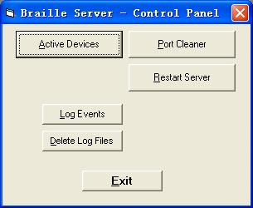

- Select “Active devices”.
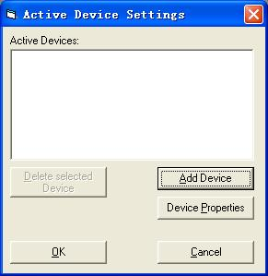

- Click on “Add device”.

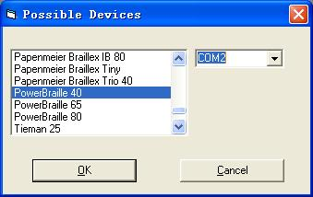

Select the desired display from the list and type the noted com port.
- Click on “OK” to reboot the Braille Server.
- Please also reboot COBRA, so that it can recognize the newBraille display.
- Start COBRA by pressing left CTRL+ALT+Shift+F7 again. This combination must be held for at least one second.

2. Navigation and Control keys function
Left Ctrl Right
Left Ctrl Left
Left Shift
Right Shift
Right Ctrl Left
Right Ctrl Right
Right Button
Left Button

Action | Key press
Scroll left | Left Button
Scroll right | Right Button
Previous item or up screen | Left Ctrl Left
Next item or down screen | Left Ctrl Right
Shift + Tab | Right Ctrl Right
Tab | Right Ctrl Left
Move navigation to focus | Left Shift
Focus is in element mode | Left Button + Left Ctrl Left
Focus is in line mode | Left Button + Left Ctrl Right
Navigation is in line mode | Left Button + Right Ctrl Left
Navigation in element mode | Left Button + Right Ctrl Right
Move navigation to the top | Left Ctrl Left + Right Ctrl Right
Move navigation to the bottom | Left Ctrl Right + Right Ctrl Left
Escape | Left Ctrl Left + Right Button
Enter | Left Ctrl Right + Right Button

Chapter 10 - Using the Perkins Products Braille Display with NVDA

1. Configuration of BRLTTY
Before using the Perkins Products Display with NVDA, please install BRLTTY (for windows) and configure BRLTTY as follows:

- Make sure that Seika Display driver has been installed successfully and the Perkins Products Braille Display has been connected with your computer.
- Run the “DetectSeikaCOMPort V1.0.exe” in the “tool” folder in the CD; remember the Seika COM port number.
- Double click “brlttycnf.exe” to chose “Seika” at Braille display list
- In the COM port list, select the noted display COM port. Click OK button to save and exit.
- Double click “install.bat” to install BRLTTY service.
- You will hear beeps when BRLTTY starts to work successfully as system service and Braille Display will update display. If not, please reboot the computer with connecting display and “brltty.exe” will run automatically.

2. Configuration of NVDA
To use the Perkins Products Display with NVDA through brltty, please configure NVDA as follows:
- Run “nvda.exe”, select “preference”, and select “Braille settings”.
- Select “brltty” at Braille display list, click OK to save and exit.

3. Reconnection
For any reconnection needs, please reboot the computer or configure brltty as follows:
- Run “uninstall.bat” to uninstall service.
- Do the same as Configuration of BRLTTY.

4. Navigation and Control keys function
Left Ctrl Right
Left Ctrl Left
Left Shift
Right Shift
Right Ctrl Left
Right Ctrl Right
Right Button
Left Button

Description | Key Press
Scroll Braille Left | Left Button
Scroll Braille Right | Right Button
Braille Prior Line | Left Ctrl Left
Braille Next Line | Left Ctrl Left

Chapter 11 - FLASH DISK READING MODE
【Caution】:The following instructions are very important:
This braille display can read BSE, BRL, BRF files.
- Please confirm that files are in the root directory of your flash disk, and the file name is not more than eight letters.

NOTE: It may be a little slow when you browse files name and read files in some brands of flash disks.

1. Quick Start
- Do not connect Braille display with a computer, turn on the Braille display.
- Plug in the flash disk.
- Push Left Button + Right Shift to enter the Flash Disk Reading Mode.
- The first file name will be displayed.
- Push Right Ctrl Left button and Right Ctrl Right button to scroll the file list.
- Push Right Shift button to open the file.
- Push Right Ctrl Left button/Right Ctrl Right button or Left button/Right button to scroll the Braille line.
- Push Left Button + Left Shift togoback to the file list.
- Push Left button + Left Shift again or pull out the flash disk to exit Flash Disk Reading Mode.
- Turn off the Braille display.

2. Control keys
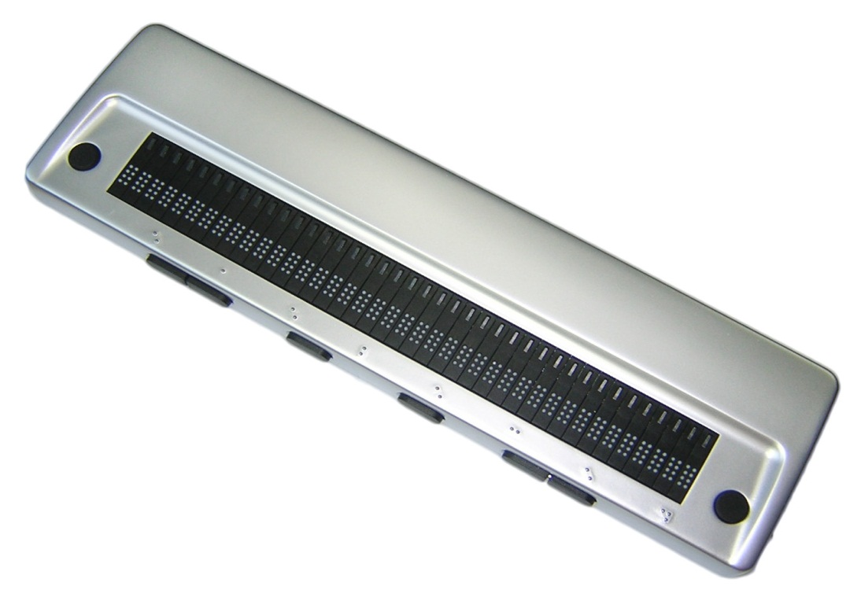
Left Ctrl Right
Left Ctrl Left
Left Shift
Right Shift
Right Ctrl Left
Right Ctrl Right
Right Button
Left Button

2.1. File Selection
When you plug in the flash disk and push Left Button + Right Shift, you will enter the Flash Disk Reading Mode, and the first file name will be displayed.
Right Ctrl Left or Left Button: Find the previous file name.
Right Ctrl Right or Right Button: Find the next file name.
Left Shift: List the first file name in the USB disk.
Right Shift: Open the file and start read the file.
Left Ctrl left: Move up ten files.
Right Ctrl left: Move down ten files.
NOTE:
“File list Top!” / “File list Bottom!” will be displayed if it reaches the top/bottom of the file list.

2.2. File Reading
Left Ctrl Left: previous page.
Left Ctrl Right: next page.
Right Ctrl Left or Left Button: previous line.
Right Ctrl Right or Right Button:next line.
Left Button + Left Shift: go back to the file list.
Right Shift: no function.

NOTE:
“This is the last line!” will be displayed if it reaches the end of the document.

3. Quit
In order to quit file reading mode, push Left Button + Left Shift twice (when you are reading the file) or only once (when you are in the file selection list). You can also pull out the flash disk to quit file reading mode. After you quit the file reading mode, the following message will be displayed:
“QUIT THE FLASH DISK MODE!”

Chapter 12 - Display Specifications

Display system | 8 dots Braille
Display capacity | 40 cells
Cursor key | 8 Control keys
Touch cursor key | 40 keys
Character code | original code
Interface | USB /MINI USB /DC
Power supply | Bus power/AC adapter/Battery
Size | 12.99(W) x 3.58(D) x 0.98 (H)inches
Weight | 640g

Q&A

1. How to verify which Virtual COM port has been used by the Perkins Products Braille Display
- Run “DetectSeikaCOMPort V1.0.exe” in the “tool” folder in the CD.
- The COM port number will be displayed.

2. How to uninstall the Braille display driver
Open the “Add or Remove Programs” in your Windows operation system, select and remove the item “Silicon Laboratories CP210x USB to UARTBridge”

NOTE: For the old version of Seika driver, select and remove the item according to the following different Windows operation system.

XP: “CP210x USB to UARTBridge Controller”
Win7 32/64bit: “Seika Braille Display System Driver (Driver Removal)”
Vista 32/64bit: “Seika Braille Display (Driver Removal)”

3. Braille display doesn’t work
If the Perkins Products Braille display doesn’t work, please check Seika Braille display driver and also the screen reader setting.

3.1 Check Seika Braille display driver
- Right click the icon of “My Computer” on desktop, and select “Properties”.
- Select “Hardware” on the top menu, and click the button “Device Manager”.

If there is a yellow interrogation mark before both the item “Other Device” and its subdirectory “Silicon Labs CP210x USB to UART Bridge” in the catalog, it would mean that Seika Braille display driver doesn’t work. It is necessary to reinstall the driver.
- Right click “Silicon Labs CP210x USB to UARTBridge”, and select “uninstall”.
- Install the Braille display driver again (refer to Chapter 3).

3.2 Check the screen reader configuration
Run the “DetectSeikaCOMPort V1.0.exe” in the “tool” folder in the CD; remember the Seika COM port number. Check the COM port setting in your screen reader.

